Movie Maker 2012 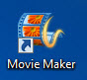
It’s a great software that will help you make your own movies.
Here are the following things you will learn.

Import () | Export () | Title () | Photos () | Transitions () | Effects()
Music () | Your Voice () | Subtitles () | Credits ()

You can find the program by searching for Movie Maker. This is a free software that is available to all Window owners.
START>Type ‘Movie Maker’
Selecte movie maker.
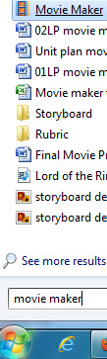

Everything you need are in these 3 bars.
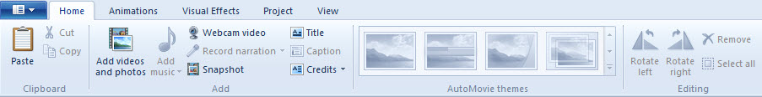

IMPORT=Bring In
DEVICE = Item (Camera, Phone.)
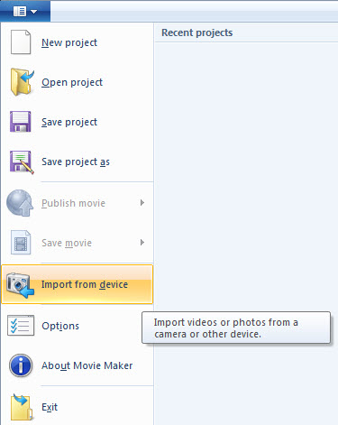
Click Add Videos and Photos to import on your computer.
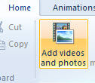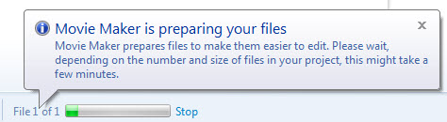
Movie maker will change the format. Only import AVI, WMV.
CONVERT the file if you are having issues.
WEBSITE for free converter. http://www.nchsoftware.com/prism/index.html

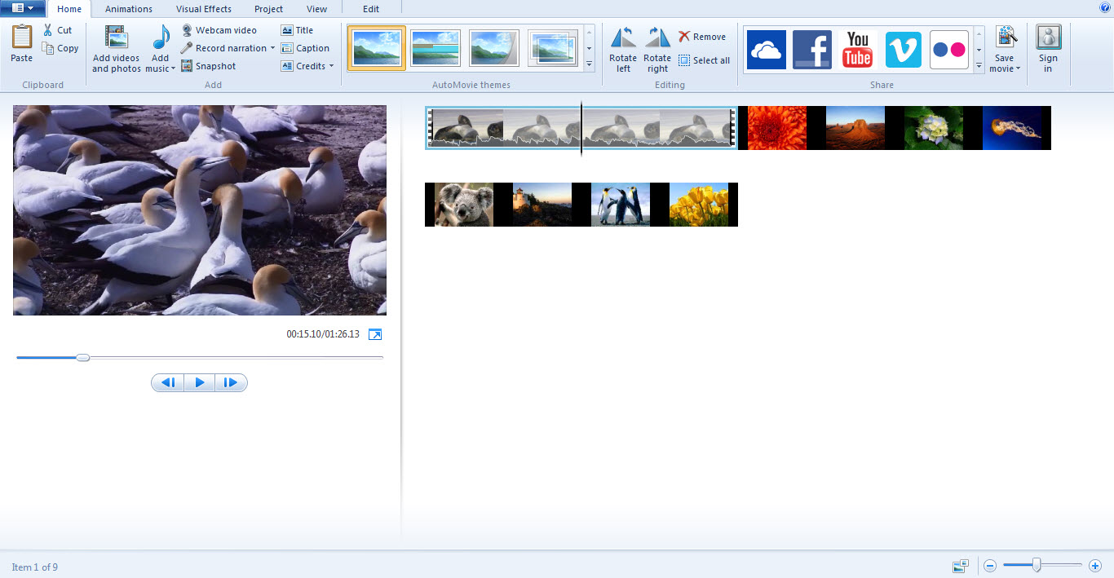
You can import as many things as you want. You can even import pictures and music. This is your timeline. It’s similar to a storyboard.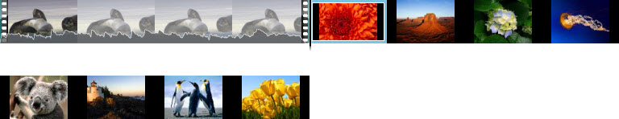

Moving pieces
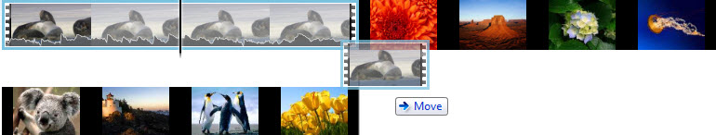
Copy and paste to make more clips.
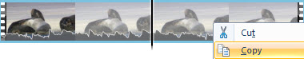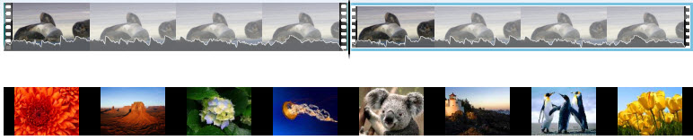

Press SPACE BAR if you want to play your video.

SET START POINT= Shorter in the front of the video clip.
SET END POINT = Shorter in the end of the video clip.
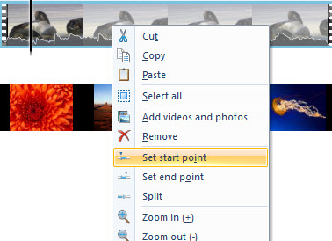
SPLIT = Cuts the clip into smaller piece.


TRANSITIONS
ANIMATION>TRANISTIONS
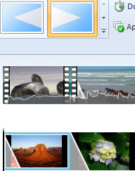 Clip with tansitions added. 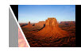

Choose a scene and then select the transitions. Idea is similar to PowerPoint.

Colour Effects= This can be found in the Video Effects Area. 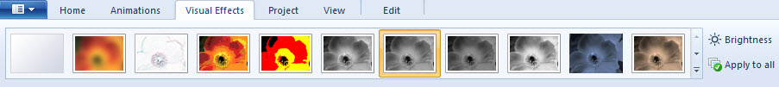
Clip that has effect on it.

TEXT
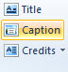
Title= Words at the beginning of the video. 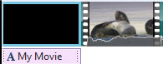
Captions=Subtitles. 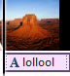
Credits= Words at the end of the video. 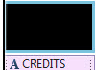
If you want to change the style or colours. Go here once you select the clip.
MUSIC.
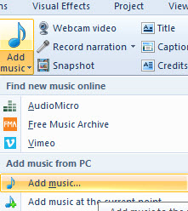
Treat it the same way that you edit videos.
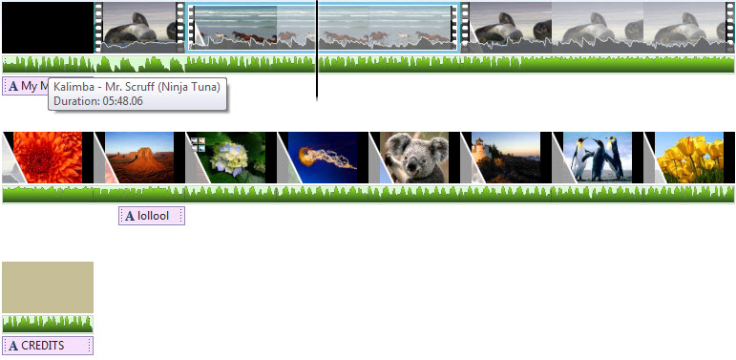
Your tools are here.
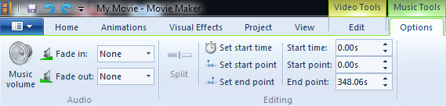

EXPORT=Produce
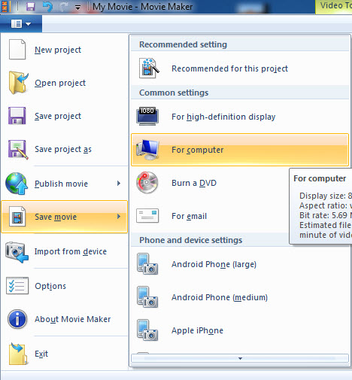
Once you finished and ready to show people your project. Click SAVE MOVIE> FOR COMPUTER.
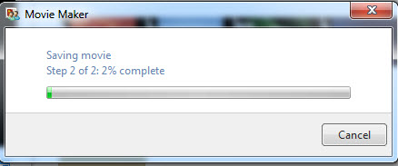 It takes time.
Give it a name and a place you want to save your work.
The bigger the file, the longer it will take to render (look it up.)
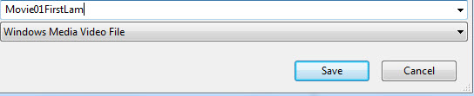

REMEMBER, REDNERING DEPENDS ON YOUR COMPUTER AND PROJECT. It can take from 1 minute to 10 hours depending on your equipment.

Assignment
Your name shows up 3-4 times without a black screen.
Title(Name of the video) at the front of the video.
At least 2 transitions.
Colour changes once, then back to normal.
Make your video longer that 30 seconds.
Play Music for 20 seconds with the movie in the back.
Add credits at the end. (Who did what)

This is marked as a checklist. If you complete all tasks in your video, you will receive full marks. Each check is worth one mark.

Movie01LastFirst

